Goals:

To learn about the architecture of computers

To learn about machine languages and higher-level programming languages

To become familiar with your compiler

To compile and run your first C++ program

To recognize compile-time and run-time errors

To describe an algorithm with pseudocode

To understand the activity of programming

Programming?

Computers carry wide range of tasks, because they execute different programs, each of which directs the computer to work on a specific task.

Computers stores data, interacts with devices and executes programs.

Computer programs tells a computer what to do.

Programming – The act of designing and implementing computer programs.

Hardware – The physical computer and peripheral devices are collectively called the hardware.

Software – The programs the computer executes are called the software.

The CPU (Central processing Unit):

Core of what performs that all the operations that you do.

* Heart of the computer
* Executes one operation at a time
* Performs program control and data processing

What it does:

* Carries arithmetic operations like addition, subtraction, multiplication and division.
* Fetches data from external memory or devices and stores data back.
* Everything travels to the CPU.

The Computer stores data and programs in memory.

Primary memory – memory chips

* Random access memory (RAM)
* Read-only memory (ROM)

Secondary Storage devices:

* Disk drives
* CDs

The computer transmits information called output.

The user can enter information called input.

Machine instructions:

* Encoded into a Pentium processor and stored.

C++ are independent of the processor type and hardware. It will work well one:

* Intel Pentium and a processor
* In a cell phone

The Compiler:

* A special computer program, that translates a program into machine instructions for processors.

Low-level language: the machine code for a specific CPU

* The compiler-generated machine instructions are different, but the programmer who uses the compiler need not worry about these differences.

Evolution of C++

“Bjarne Stroustrup” of AT&T adds features of the language Simula to C (1972), resulting in C++ (1985)

C++ is a general purpose language used for developing system software such as databases and operating systems.

IDE (Integrated development environment) is the place you will most likely work.

Program is called a source file.

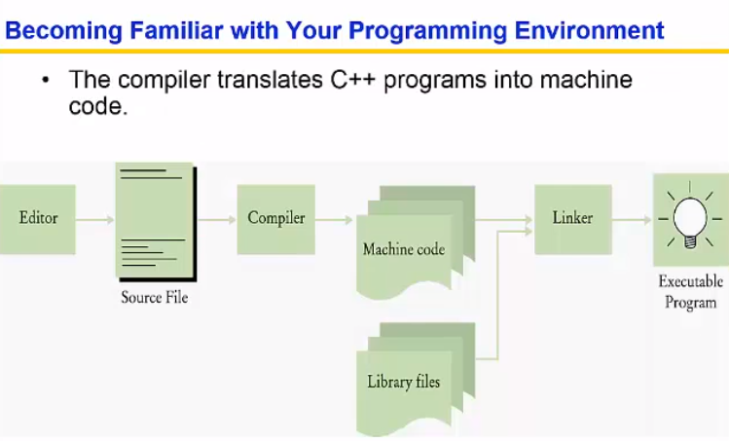

Errors:

* Every C++ program must have one and only one main function.
* Most C++ programs contain other functions besides main.
* Errors are mostly due controlled words like “Main” and C++ is case sensitive.

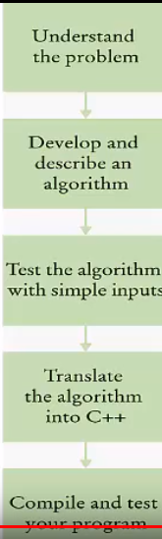

Algorithms:

Step-by-step process that you go through.

Pseudocode:

* An informal description
* Must be unambiguous, precise instructions and where to go.
* Executable.
* Terminating

Example of Pseudocode:

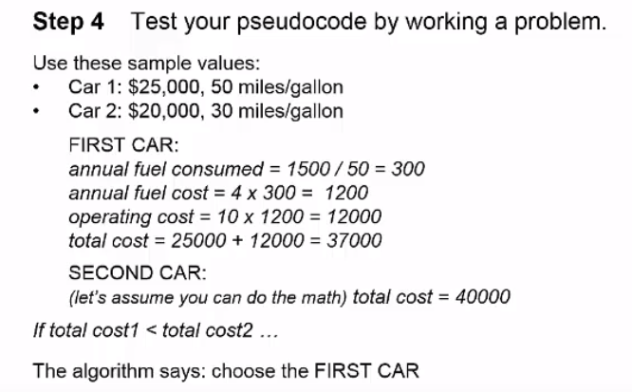

Summary:

* Computers execute basic instructions in succession.
* Computer program sequence of instructions and decisions.
* Programming is act of designing and implementing computer programs.

Components of computer:

* CPU performs program control and data processing.
* Storage devices include memory and secondary storage.
* Computer programs are stored as machine instructions in a code that depends on the processor type.

C++:

* An editor is a program for entering and modifying text.
* C++ is case sensitive.
* Keep backup copies of your work.
* Compiler translate C++ programs into machine code.
* The linker combines machine code with library code into an executable program.

How to use C++:

* Every program contains a function called main.
* Use **cout** and the **<<** operator to display values on the screen.
* Enclose text strings in quotation marks.
* Use **+** to add two numbers and **\*** to multiply two numbers.
* Send **endl** to **cout** to end a line of displayed output.
* End each statement with a semicolon ( ; )

Classifying errors:

* A compile-time error is a violation of the programming language rules that is detected by the compiler.
* A run-time error causes a program to take an action that the programmer did not intend.